19162121031

SMIT R PATEL

BDA

SEM 5

PRACTICAL 12

Here, first of all we make directory p12 in Hadoop and put file 2008.csv and airports.csv in p12 directory from Cloudera Desktop :

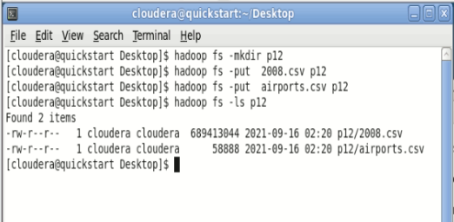

1 Create hive table, flight_data:

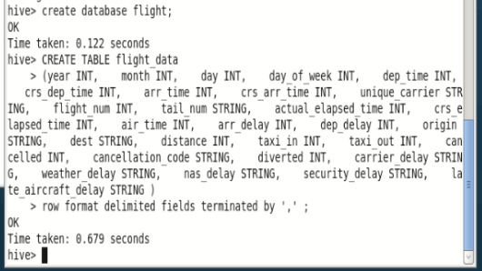

2 Load the data into the table:

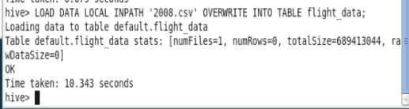

3 Ensure the table got created and loaded fine:

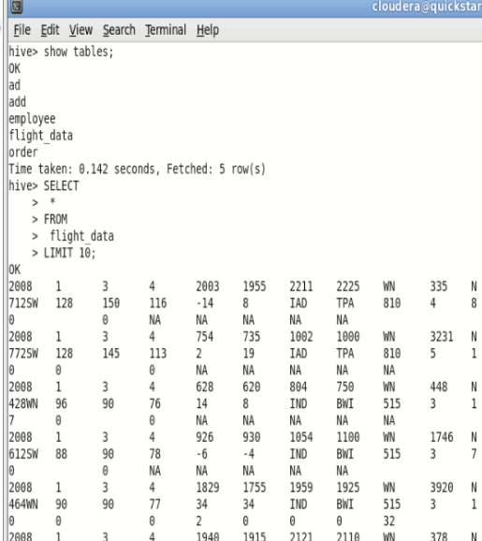

4 Query the table. Find average arrival delay for all flights departing SFO in January:

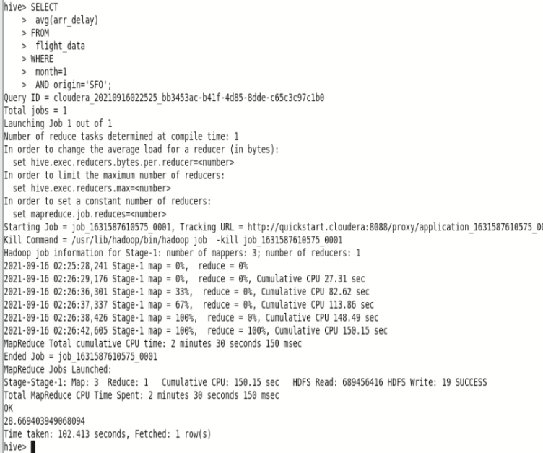

5 On hive shell: create the airports table

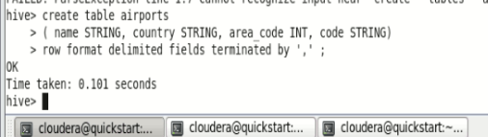

6 Load data into airports table:

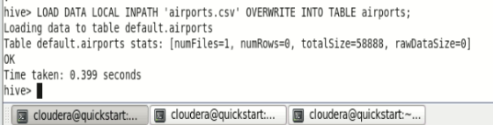

7 On hive shell, list some rows from the airports table:

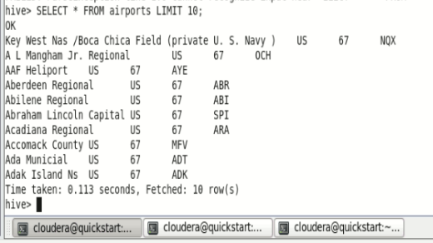

8 On hive shell: run a join query to find the average delay in January 2008 for each airport and to print out the airport's name:

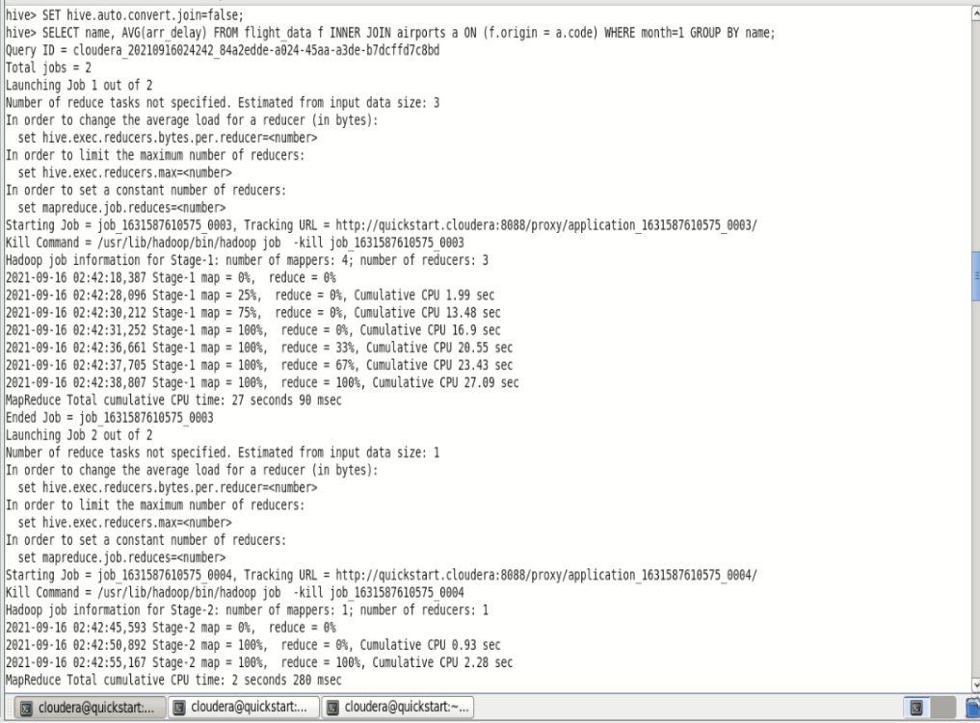

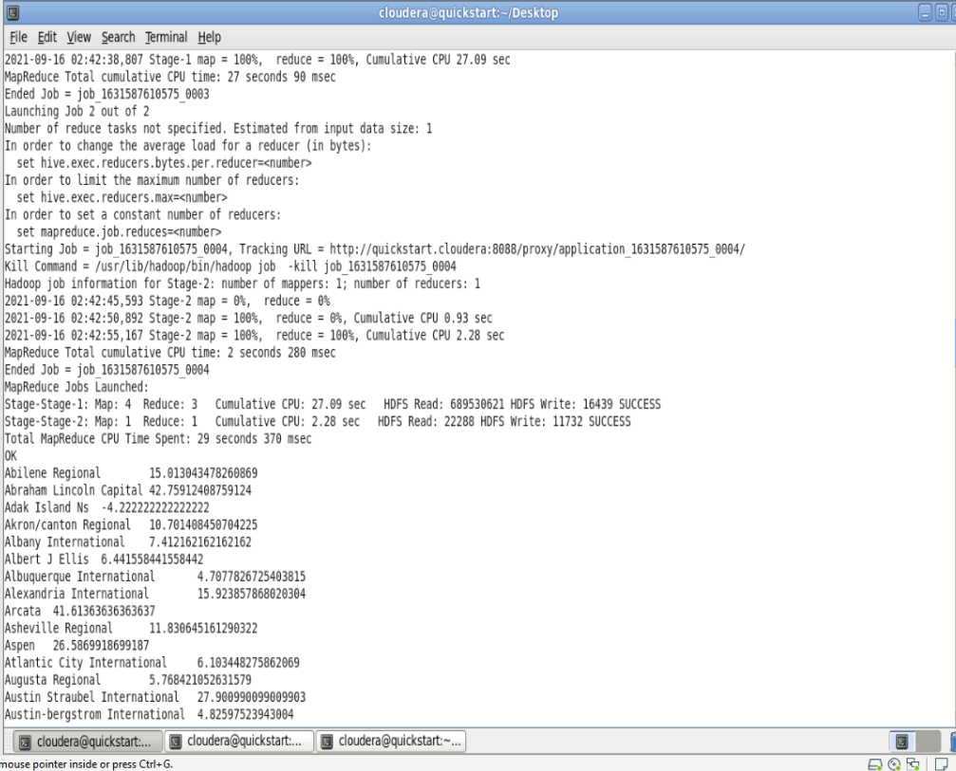

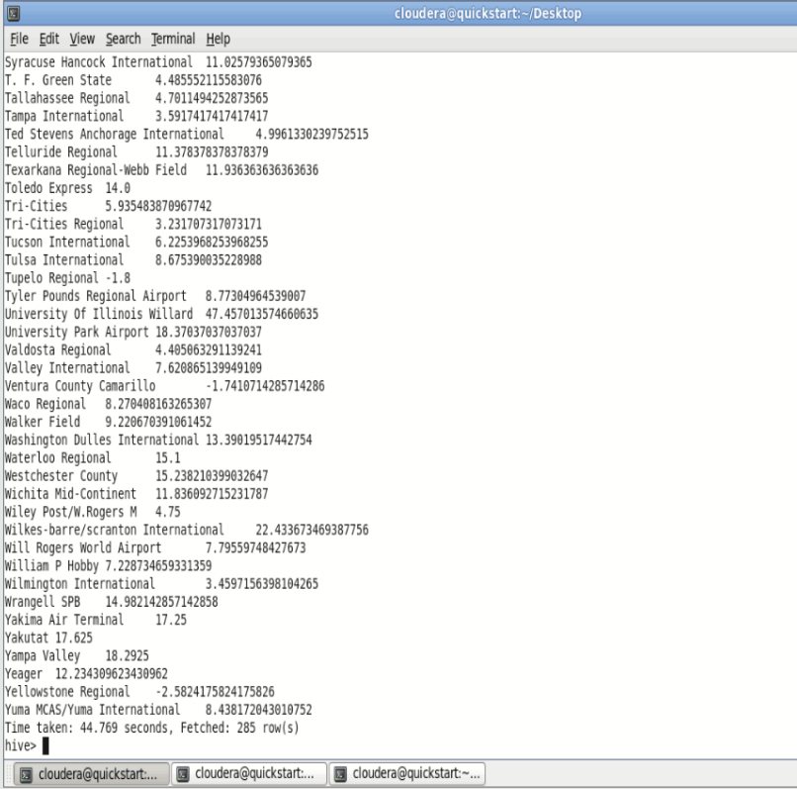

Extra

